INTRODUCTION
The important resource in contemporary marketing strategies is Customers. Therefore, it is essential to enterprises and organization to successfully acquire new customers and retain high value customers. To achieve these aims, many enterprises plan to gain their own customers' data with many of database tools which can be analyzed to achieve the customer behavioral and applied to develop new business strategies.
Accordingly, assuming there is same pattern between customer behaviors. Many method have been introduced to achieve better knowing of customer behaviors, the "behavioral scoring models" is one of the most successful technique that help decision makers to realize their customer behaviors. Behavioral scoring models help to analyze purchasing behavior of customers.
The banking industry around the world has undergone a tremendous change in the way business is conducted. Leading banks are using Data Mining (DM) tools for customer segmentation and profitability, credit scoring and approval, predicting payment default, marketing, detecting fraudulent transactions, etc.
Today, data mining is being used by several industries including banking and finance, retail, insurance, telecommunications, etc. Other possible applications for data mining include database marketing, sales forecasting, call behavior analysis and churning management in telecommunications; forecasting of demand for utilities, such as energy and water; simulation of chemical and other process reactions; finding critical factors in discrete manufacturing (aerospace, automobile, electronics); CPU usage and forecasting. Data mining is often referred to as ‘analytical intelligence’.
Currently, huge electronic data repositories are being maintained by banks and other financial institutions across the globe. Valuable bits of information are embedded in these data repositories. The huge size of these data sources make it impossible for a human analyst to come up with interesting information that will help in the decision making process
Data mining can contribute to solving business problems in banking and finance by finding patterns, causalities, and correlations in business information and market prices that are not immediately apparent to managers because the volume data is too large or is generated too quickly to screen by experts.
The managers of the banks may go a step further to find the sequences, episodes and periodicity of the transaction behavior of their customers which may help them in actually better segmenting, targeting, acquiring, retaining and maintaining a profitable customer base. Business Intelligence and data mining techniques can also help them in identifying various classes of customers and come up with a class based product and/or pricing approach that may garner better revenue management as well.
Customer Behavior Modeling (CBM) or customer profiling is a tool to predict the future value of an individual and the risk category to which he belongs to based on his demographic characteristics, life-style and previous behavior. This helps to focus on customer retention.
To achieve these aims, many enterprises plan to gain their own customers' data with many of database tools which can be analyzed to achieve the customer behavioral and applied to develop new business strategies. Economic theory has established that a business derives 80% of its income from 20% of its customers. However, instead of targeting all prospects equally or providing the same offers to all customers, enterprises select only those individuals that meet specified profitability levels based on previous behavior or individual needs. Accordingly, assuming there is same pattern between customer behaviors.
Many method have been introduced to achieve better knowing of customer behaviors, the "behavioral scoring models" is one of the most successful technique that help decision makers to realize their customer behaviors. Behavioral scoring models help to analyze purchasing behavior of customers. These models are highly applying data mining approaches. For a bank, most existing data mining approaches were discovered rules and predicted bankruptcy probability in a bank database. Few works have focused on the analyzing of bank databases from the viewpoint of customer behavioral analyze. More specifically we wanted to look at both the customers profile data and their debit cards transactions. With these data, the aim was to discover applied patterns or rules in the data that could provide information about what incentives a company could offer as better marketing strategies to its customers.

- SYSTEM ANALYSIS

  - Existing System
The existing system determine the new two-stage framework of customer behavior analysis using K-means clustering algorithm and an association rule inducer for analyzing bank databases. For differentiation purposes, the system grouped customers with shared customer behavior and RFM value.

After briefly reviewed the customer profiles using the association rule inducer, the customers with a higher CP or RFM might be the target customer groups of precedence. The existing customers were divided into three profitable groups of customers according to their shared behavior and characteristics. Marketers then can infer the profiles of customers in each group and propose management strategies appropriate to the each group. This method of analyzing bank databases was analyzing slow process of the large system. Beyond simply understanding customer value, the bank gains the opportunities to establish better customer relationships.

2.2 Proposed System
Sequence ranking is critical for many CRM applications such as customer churning behavior classification. A major problem for this research is how to resolve the many sequences which are ambiguous in that they confuse between positive and negative instances during classification.
Also to analyze customer characteristics and behaviors with appropriated criteria: access time, transaction access. The benefits are valuable for the bank to improve services. These results might be benefit for banking marketing team to launch a suitable promotion for appropriate clustering.
To implement the Time series transformation approach which one to find the Maximum Likelyhood (Calculate Mean) values with the use of EM (Expectation Maximization) Algorithm.

Marketers then can infer the profiles of customers in each group and propose management strategies appropriate to the each group. This study provides a new method of analyzing bank databases. Beyond simply understanding customer value, the bank gains the opportunities to establish better customer relationships
3. SYSTEM CONFIGURATION

3.1 HARDWARE SPECIFICATION

PROCESSOR : Intel Pentium IV Processor
SPEED : 1.7 GHZ
RAM : 512 MB
HARD DISK : 40 GB
MOUSE : 2 or 3 button mouse
KEYBOARD : 101 key Keyboard.

3.2 SOFTWARE SPECIFICATION

OPERATING SYSTEM : Windows 2000 Professional
FRONT END : Visual C# .Net 2005
BACK END : MS – SQL Server 2005

4. SOFTWARE DESCRIPTION

4.1 ABOUT THE FRONDEND
INTRODUCTION TO .NET FRAMEWORK
The Microsoft .NET Framework is a software technology that is available with several Microsoft Windows operating systems. It includes a large library of pre-coded solutions to common programming problems and a virtual machine that manages the execution of programs written specifically for the framework. The .NET Framework is a key Microsoft offering and is intended to be used by most new applications created for the Windows platform.
The pre-coded solutions that form the framework's Base Class Library cover a large range of programming needs in a number of areas, including user interface, data access, database connectivity, cryptography, web application development, numeric algorithms, and network communications. The class library is used by programmers, who combine it with their own code to produce applications.
Programs written for the .NET Framework execute in a software environment that manages the program's runtime requirements. Also part of the .NET Framework, this runtime environment is known as the Common Language Runtime (CLR). The CLR provides the appearance of an application virtual machine so that programmers need not consider the capabilities of the specific CPU that will execute the program. The CLR also provides other important services such as security, memory management, and exception handling. The class library and the CLR together compose the .NET Framework.

Principal design features
Interoperability
Because interaction between new and older applications is commonly required, the .NET Framework provides means to access functionality that is implemented in programs that execute outside the .NET environment. Access to COM components is provided in the System.Runtime.InteropServices and System.EnterpriseServices namespaces of the framework; access to other functionality is provided using the P/Invoke feature.
Common Runtime Engine
The Common Language Runtime (CLR) is the virtual machine component of the .NET framework. All .NET programs execute under the supervision of the CLR, guaranteeing certain properties and behaviors in the areas of memory management, security, and exception handling.
Base Class Library
The Base Class Library (BCL), part of the Framework Class Library (FCL), is a library of functionality available to all languages using the .NET Framework. The BCL provides classes which encapsulate a number of common functions, including file reading and writing, graphic rendering, database interaction and XML document manipulation.
Simplified Deployment
Installation of computer software must be carefully managed to ensure that it does not interfere with previously installed software, and that it conforms to security requirements. The .NET framework includes design features and tools that help address these requirements.
Security
The design is meant to address some of the vulnerabilities, such as buffer overflows, that have been exploited by malicious software. Additionally, .NET provides a common security model for all applications.
Portability
The design of the .NET Framework allows it to theoretically be platform agnostic, and thus cross-platform compatible. That is, a program written to use the framework should run without change on any type of system for which the framework is implemented. Microsoft's commercial implementations of the framework cover Windows, Windows CE, and the Xbox 360. In addition, Microsoft submits the specifications for the Common Language Infrastructure (which includes the core class libraries, Common Type System, and the Common Intermediate Language), the C# language, and the C++/CLI language to both ECMA and the ISO, making them available as open standards. This makes it possible for third parties to create compatible implementations of the framework and its languages on other platforms.

Architecture
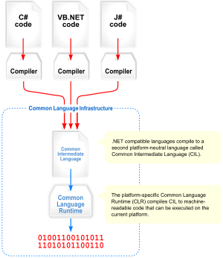
Visual overview of the Common Language Infrastructure (CLI)
Common Language Infrastructure
The core aspects of the .NET framework lie within the Common Language Infrastructure, or CLI. The purpose of the CLI is to provide a language-neutral platform for application development and execution, including functions for exception handling, garbage collection, security, and interoperability. Microsoft's implementation of the CLI is called the Common Language Runtime or CLR.
Assemblies
The intermediate CIL code is housed in .NET assemblies. As mandated by specification, assemblies are stored in the Portable Executable (PE) format, common on the Windows platform for all DLL and EXE files. The assembly consists of one or more files, one of which must contain the manifest, which has the metadata for the assembly. The complete name of an assembly (not to be confused with the filename on disk) contains its simple text name, version number, culture, and public key token. The public key token is a unique hash generated when the assembly is compiled, thus two assemblies with the same public key token are guaranteed to be identical from the point of view of the framework. A private key can also be specified known only to the creator of the assembly and can be used for strong naming and to guarantee that the assembly is from the same author when a new version of the assembly is compiled (required to add an assembly to the Global Assembly Cache).
Metadata
All CLI is self-describing through .NET metadata. The CLR checks the metadata to ensure that the correct method is called. Metadata is usually generated by language compilers but developers can create their own metadata through custom attributes. Metadata contains information about the assembly, and is also used to implement the reflective programming capabilities of .NET Framework.
Security
.NET has its own security mechanism with two general features: Code Access Security (CAS), and validation and verification. Code Access Security is based on evidence that is associated with a specific assembly. Typically the evidence is the source of the assembly (whether it is installed on the local machine or has been downloaded from the intranet or Internet). Code Access Security uses evidence to determine the permissions granted to the code. Other code can demand that calling code is granted a specified permission. The demand causes the CLR to perform a call stack walk: every assembly of each method in the call stack is checked for the required permission; if any assembly is not granted the permission a security exception is thrown.
When an assembly is loaded the CLR performs various tests. Two such tests are validation and verification. During validation the CLR checks that the assembly contains valid metadata and CIL, and whether the internal tables are correct. Verification is not so exact. The verification mechanism checks to see if the code does anything that is 'unsafe'. The algorithm used is quite conservative; hence occasionally code that is 'safe' does not pass. Unsafe code will only be executed if the assembly has the 'skip verification' permission, which generally means code that is installed on the local machine.
.NET Framework uses appdomains as a mechanism for isolating code running in a process. Appdomains can be created and code loaded into or unloaded from them independent of other appdomains. This helps increase the fault tolerance of the application, as faults or crashes in one appdomain do not affect rest of the application. Appdomains can also be configured independently with different security privileges. This can help increase the security of the application by isolating potentially unsafe code. The developer, however, has to split the application into sub domains; it is not done by the CLR.
Class library
Namespaces in the BCL
System
System. CodeDom
System. Collections
System. Diagnostics
System. Globalization
System. IO
System. Resources
System. Text
System.Text.RegularExpressions
Microsoft .NET Framework includes a set of standard class libraries. The class library is organized in a hierarchy of namespaces. Most of the built in APIs are part of either System.* or Microsoft.* namespaces. It encapsulates a large number of common functions, such as file reading and writing, graphic rendering, database interaction, and XML document manipulation, among others. The .NET class libraries are available to all .NET languages. The .NET Framework class library is divided into two parts: the Base Class Library and the Framework Class Library.
The Base Class Library (BCL) includes a small subset of the entire class library and is the core set of classes that serve as the basic API of the Common Language Runtime. The classes in mscorlib.dll and some of the classes in System.dll and System.core.dll are considered to be a part of the BCL. The BCL classes are available in both .NET Framework as well as its alternative implementations including .NET Compact Framework, Microsoft Silver light and Mono.
The Framework Class Library (FCL) is a superset of the BCL classes and refers to the entire class library that ship with .NET Framework. It includes an expanded set of libraries, including Win Forms, ADO.NET, ASP.NET, Language Integrated Query, Windows Presentation Foundation, Windows Communication Foundation among others. The FCL is much larger in scope than standard libraries for languages like C++, and comparable in scope to the standard libraries of Java.
Memory management
The .NET Framework CLR frees the developer from the burden of managing memory (allocating and freeing up when done); instead it does the memory management itself. To this end, the memory allocated to instantiations of .NET types (objects) is done contiguously from the managed heap, a pool of memory managed by the CLR. As long as there exists a reference to an object, which might be either a direct reference to an object or via a graph of objects, the object is considered to be in use by the CLR. When there is no reference to an object, and it cannot be reached or used, it becomes garbage. However, it still holds on to the memory allocated to it. .NET Framework includes a garbage collector which runs periodically, on a separate thread from the application's thread, that enumerates all the unusable objects and reclaims the memory allocated to them.
The .NET Garbage Collector (GC) is a non-deterministic, compacting, mark-and-sweep garbage collector. The GC runs only when a certain amount of memory has been used or there is enough pressure for memory on the system. Since it is not guaranteed when the conditions to reclaim memory are reached, the GC runs are non-deterministic. Each .NET application has a set of roots, which are pointers to objects on the managed heap (managed objects). These include references to static objects and objects defined as local variables or method parameters currently in scope, as well as objects referred to by CPU registers. When the GC runs, it pauses the application, and for each object referred to in the root, it recursively enumerates all the objects reachable from the root objects and marks them as reachable. It uses .NET metadata and reflection to discover the objects encapsulated by an object, and then recursively walk them. It then enumerates all the objects on the heap (which were initially allocated contiguously) using reflection. All objects not marked as reachable are garbage. This is the mark phase. Since the memory held by garbage is not of any consequence, it is considered free space. However, this leaves chunks of free space between objects which were initially contiguous. The objects are then compacted together, by using memory ^{to} copy them over to the free space to make them contiguous again. Any reference to an object invalidated by moving the object is updated to reflect the new location by the GC. The application is resumed after the garbage collection is over.
The GC used by .NET Framework is actually generational. Objects are assigned a generation; newly created objects belong to Generation 0. The objects that survive a garbage collection are tagged as Generation 1, and the Generation 1 objects that survive another collection are Generation 2 objects. The .NET Framework uses up to Generation 2 objects. Higher generation objects are garbage collected less frequently than lower generation objects. This helps increase the efficiency of garbage collection, as older objects tend to have a larger lifetime than newer objects. Thus, by removing older (and thus more likely to survive a collection) objects from the scope of a collection run, fewer objects need to be checked and compacted.
Versions: Microsoft started development on the .NET Framework in the late 1990s originally under the name of Next Generation Windows Services (NGWS). By late 2000 the first beta versions of .NET 1.0 were released.
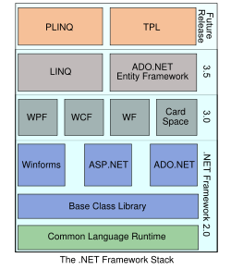
C#.NET
The C# language is disarmingly simple, with only about 80 keywords and a dozen built-in datatypes, but C# is highly expressive when it comes to implementing modern programming concepts. C# includes all the support for structured, component-based, object-oriented programming that one expects of a modern language built on the shoulders of C++ and Java. The C# language was developed by a small team led by two distinguished Microsoft engineers, Anders Hejlsberg and Scott Wiltamuth. Hejlsberg is also known for creating Turbo Pascal, a popular language for PC programming, and for leading the team that designed Borland Delphi, one of the first successful integrated development environments for client/server programming.
At the heart of any object-oriented language is its support for defining and working with classes. Classes define new types, allowing you to extend the language to better model the problem you are trying to solve. C# contains keywords for declaring new classes and their methods and properties, and for implementing encapsulation, inheritance, and polymorphism, the three pillars of object-oriented programming.
In C# everything pertaining to a class declaration is found in the declaration itself. C# class definitions do not require separate header files or Interface Definition Language (IDL) files. Moreover, C# supports a new XML style of inline documentation that greatly simplifies the creation of online and print reference documentation for an application.
C# also supports interfaces, a means of making a contract with a class for services that the interface stipulates. In C#, a class can inherit from only a single parent, but a class can implement multiple interfaces. When it implements an interface, a C# class in effect promises to provide the functionality the interface specifies.
C# also provides support for structs, a concept whose meaning has changed significantly from C++. In C#, a struct is a restricted, lightweight type that, when instantiated, makes fewer demands on the operating system and on memory than a conventional class does. A struct can't inherit from a class or be inherited from, but a struct can implement an interface.

C# provides component-oriented features, such as properties, events, and declarative constructs (called attributes). Component-oriented programming is supported by the CLR's support for storing metadata with the code for the class. The metadata describes the class, including its methods and properties, as well as its security needs and other attributes, such as whether it can be serialized; the code contains the logic necessary to carry out its functions. A compiled class is thus a self-contained unit; therefore, a hosting environment that knows how to read a class' metadata and code needs no other information to make use of it. Using C# and the CLR, it is possible to add custom metadata to a class by creating custom attributes. Likewise, it is possible to read class metadata using CLR types that support reflection.
An assembly is a collection of files that appear to the programmer to be a single dynamic link library (DLL) or executable (EXE). In .NET, an assembly is the basic unit of reuse, versioning, security, and deployment. The CLR provides a number of classes for manipulating assemblies.
A final note about C# is that it also provides support for directly accessing memory using C++ style pointers and keywords for bracketing such operations as unsafe, and for warning the CLR garbage collector not to collect objects referenced by pointers until they are released.
C# .Net Features
- C# is a simple, modern, object oriented language derived from C++ and Java.
- It aims to combine the high productivity of Visual Basic and the raw power of C++.
- It is a part of Microsoft Visual Studio7.0.
- Visual studio supports Vb, VC++, C++, Vbscript, Jscript. All of these languages provide access to the Microsoft .NET platform.
- .NET includes a Common Execution engine and a rich class library.
- Microsoft's JVM equiv. is Common language run time (CLR).
- CLR accommodates more than one languages such as C#, VB.NET, Jscript, ASP.NET, C++.
- Source code --->Intermediate Language code (IL) ---> (JIT Compiler) Native code.
- The classes and data types are common to all of the .NET languages.
- We may develop Console application, Windows application, and Web application using C#.
- In C# Microsoft has taken care of C++ problems such as Memory management, pointers etc.
- It supports garbage collection, automatic memory management and a lot.

ADO.NET OVERVIEW
ADO.NET is an evolution of the ADO data access model that directly addresses user requirements for developing scalable applications. It was designed specifically for the web with scalability, statelessness, and XML in mind.
ADO.NET uses some ADO objects, such as the Connection and Command objects, and also introduces new objects. Key new ADO.NET objects include the Dataset, Data Reader, and Data Adapter.
The important distinction between this evolved stage of ADO.NET and previous data architectures is that there exists an object -- the DataSet -- that is separate and distinct from any data stores. Because of that, the DataSet functions as a standalone entity. You can think of the DataSet as an always disconnected recordset that knows nothing about the source or destination of the data it contains. Inside a DataSet, much like in a database, there are tables, columns, relationships, constraints, views, and so forth.
A DataAdapter is the object that connects to the database to fill the DataSet. Then, it connects back to the database to update the data there, based on operations performed while the DataSet held the data. In the past, data processing has been primarily connection-based. Now, in an effort to make multi-tiered apps more efficient, data processing is turning to a message-based approach that revolves around chunks of information. At the center of this approach is the DataAdapter, which provides a bridge to retrieve and save data between a DataSet and its source data store. It accomplishes this by means of requests to the appropriate SQL commands made against the data store.
The XML-based DataSet object provides a consistent programming model that works with all models of data storage: flat, relational, and hierarchical. It does this by having no 'knowledge' of the source of its data, and by representing the data that it holds as collections and data types. No matter what the source of the data within the DataSet is, it is manipulated through the same set of standard APIs exposed through the DataSet and its subordinate objects.
While the DataSet has no knowledge of the source of its data, the managed provider has detailed and specific information. The role of the managed provider is to connect, fill, and persist the DataSet to and from data stores. The OLE DB and SQL Server .NET Data Providers (System.Data.OleDb and System.Data.SqlClient) that are part of the .Net Framework provide four basic objects: the Command, Connection, DataReader and DataAdapter. In the remaining sections of this document, we'll walk through each part of the DataSet and the OLE DB/SQL Server .NET Data Providers explaining what they are, and how to program against them.
The following sections will introduce you to some objects that have evolved, and some that are new.
These objects are:
- Connections. For connection to and managing transactions against a database.
- Commands. For issuing SQL commands against a database.
- DataReaders. For reading a forward-only stream of data records from a SQL Server data source.
- DataSet. For storing, Remoting and programming against flat data, XML data and relational data.
- DataAdapters. For pushing data into a DataSet, and reconciling data against a database.
When dealing with connections to a database, there are two different options: SQL Server .NET Data Provider (System.Data.SqlClient) and OLE DB .NET Data Provider (System.Data.OleDb). In these samples we will use the SQL Server .NET Data Provider. These are written to talk directly to Microsoft SQL Server. The OLE DB .NET Data Provider is used to talk to any OLE DB provider (as it uses OLE DB underneath).
Connections:
Connections are used to 'talk to' databases, and are represented by provider-specific classes such as SqlConnection. Commands travel over connections and resultsets are returned in the form of streams which can be read by a DataReader object, or pushed into a DataSet object.
Commands:
Commands contain the information that is submitted to a database, and are represented by provider-specific classes such as SqlCommand. A command can be a stored procedure call, an UPDATE statement, or a statement that returns results. You can also use input and output parameters, and return values as part of your command syntax. The example below shows how to issue an INSERT statement against the Northwind database.
DataReaders:
The DataReader object is somewhat synonymous with a read-only/forward-only cursor over data. The DataReader API supports flat as well as hierarchical data. A DataReader object is returned after executing a command against a database. The format of the returned DataReader object is different from a recordset. For example, you might use the DataReader to show the results of a search list in a web page.
DATASETS AND DATAADAPTERS:
DataSets
DataSet object is similar to the ADO Recordset object, but more powerful, and with one other important distinction: the DataSet is always disconnected. The DataSet object represents a cache of data, with database-like structures such as tables, columns, relationships, and constraints. However, though a DataSet can and does behave much like a database, it is important to remember that DataSet objects do not interact directly with databases, or other source data. This allows the developer to work with a programming model that is always consistent, regardless of where the source data resides. Data coming from a database, an XML file, from code, or user input can all be placed into DataSet objects. Then, as changes are made to the DataSet they can be tracked and verified before updating the source data. The GetChanges method of the DataSet object actually creates a second DatSet that contains only the changes to the data. This DataSet is then used by a DataAdapter (or other objects) to update the original data source.
The DataSet has many XML characteristics, including the ability to produce and consume XML data and XML schemas. XML schemas can be used to describe schemas interchanged via WebServices. In fact, a DataSet with a schema can actually be compiled for type safety and statement completion.
DATAADAPTERS (OLEDB/SQL)
The Data Adapter object works as a bridge between the DataSet and the source data. Using the provider-specific SqlDataAdapter (along with its associated SqlCommand and SqlConnection) can increase overall performance when working with a Microsoft SQL Server databases. For other OLE DB-supported databases, you would use the OleDbDataAdapter object and its associated OleDbCommand and OleDbConnection objects.
The DataAdapter object uses commands to update the data source after changes have been made to the DataSet. Using the Fill method of the DataAdapter calls the SELECT command; using the Update method calls the INSERT, UPDATE or DELETE command for each changed row.
The project can explicitly set these commands in order to control the statements used at runtime to resolve changes, including the use of stored procedures. For ad-hoc scenarios, a CommandBuilder object can generate these at run-time based upon a select statement. However, this run-time generation requires an extra round-trip to the server in order to gather required metadata, so explicitly providing the INSERT, UPDATE, and

4.2 ABOUT THE BACKEND

SQL SERVER
Today, the relational database at the core of the information systems for many organizations, public and private, large and small. Informix, Sybase, oracle and SQL Server having worldwide acceptance.
SQL Server 2000 is a Structured Query Language (SQL) based client server
Relational Database Management System (RDMS).

Client Server
This system is made up of a group of client. In this system, the server is at the central location and manages the resources that are used by the different clients situated at different locations. In this system the database files and DBMS software reside in the server. SQL Server is capable of managing hundreds of clients. This does not mean that SQL Server can’t be stand-alone. It can easily run directly on stand-alone client.
Structured Query Language (SQL)
To communicate or work with the data stored in the database, there area proper set of commands and statements defined by the DBMS software. There are lots of languages that can be used for communicating with the relational database. The SQL is the most popular language used for communicating with the relational databases. ANSI and ISO both have defined standard for SQL.

SQL Server features
SQL Server 2000 includes many new features that extend its capabilities as a high performance relational database system with a rich development environment. In addition to Transact-SQL enhancements, many internal changes have been made to improve the performance, scalability and reliability of SQL Server. This includes support for 32 processors and 64 GB of memory. SQL Server 2000 has further established its position as the fastest database in the world.

Supports Unicode data type
SQL Server 2000 supports Unicode data type. This data type allows storage of data belonging to different languages into in database. This is an in-built feature of SQL Server 2000.

Supports full text Search
SQL Server 2000 provides full-text searches for character-based data that is stored in tables. This facility can be used to create special indexes of all-important words in selected columns of selected tables. Support is provided for several languages.
Supports multi site management
SQL Server can manage multiple servers using one centralized server. Two or more servers can be grouped together into logical functioning units by business units or by department names. In addition to these enhancements, SQL Server now supports multiple instances of the database engine running concurrently on the same computer, each having its own set of system and user databases. Application can connect to each database engine instance on a computer in much the same way they connect to database engines running of different computers.

Easy to install
SQL Server can manage multiple servers using once centralized server. Two or more servers can be grouped together into logical functioning units by business units or by department’s names. In addition to these enhancements, SQL server now supports multiple instances of the database engine running concurrently on the same computer, each having its own set of system and user databases. Applications can connect to each database engine instance on a computer in much the same way they connect to database engines running of different computers.
Scalability:
SQL server 2000 easily runs on windows 95/98/NT, Windows 2000 Server. This means that a single program is shared on all environments.

Data Replication
SQL Server 2000 provides the facility of automatic replication of data. Replication means transfer of data from one geographical location by maintaining the copies of the original data.

Data Marts and Data Warehousing
Internally the database is divided into two parts. One part is transaction oriented and the second part is decision-support. The transaction-oriented database is used to perform addition of new records, modification and deletion of existing records, whereas the decision-support is used to retrieve the data stored in it. When a single database is in use for performing both data manipulation and data retrieval simultaneously, then it creates a conflict that degrades the performance of the database. For preventing a database form such conflicts, data marts and data warehouses came into the picture. Date marts and data warehouse copy the data from the decision-support database for querying on the data easily without affecting data manipulation.

English Query
This feature is used for helping uses that do not know SQL statements to query on the data. This feature allows those users to use simple English in place of SQL statements
Date Transferring services
This feature makes the movement of data. This feature also allows direct transferring of data between SQL Server 2000 and other databases like MS Access or Oracle.
User defined function
User-defined functions are similar to stored procedures and can be executed as such, or they can be executed in the same fashion as a system. Like stored procedure, they accept zero or more parameters but can return a scalar data type.

5. SYSTEM DESIGN

5.1 MODULE DESCRIPTION
PREPARING THE DATA SETS
For this work, bank databases were provided by a UCI banking dataset. Data preprocessing was required to ensure data field consistency in behavioral scoring model building. Obviously, not all the data are related to the chosen purposes, so knowledge extraction from the bank databases included the following three sub actions. The first sub-action was intended to organize the raw data.
ANALYZING THE CONSUMER BEHAVIOR
Over the years Data mining (DM) can used to understand the consumer buying behavior using various techniques. Data mining has gradually increases many folds and today it is a giant 100 billion dollar industry. In data mining world every activity of a consumer in a supermarket is treated as a byte of data.
How the consumer spends, which day what time normally he/she does the shopping, what they buy most often, how much they buy, in that locality etc. All this data which is gathered somewhere at the backend about which a consumer is not even aware and there is a big industry which is slicing & dicing this data & selling it at a premium price.
Banks seeking newer and better ways to differentiate themselves from their competitors, customer clustering one of important way to rich this result; Customer clustering is the use of past transaction data to divide customer to the similar groups. The results produced are based on the assumptions that the customer behavior follows patterns similar to past pattern and repeats in the future. Therefore, there could not be a better time than now to analyze the importance of an effective new marketing strategy using the customer behavior analyze.
The decisions to be made include which target groups of customers will be encouraged to use more, what terminal type to assign, how estimated probability of acceptance new products, whether to promote new products to target groups of customers, and, how to manage groups of customers to rich the customer satisfaction and direct marketing.
TIME SERIES DATA ANALYSIS
Just like static data clustering, time series clustering requires a clustering algorithm or procedure to form clusters given a set of unlabeled data objects and the choice of clustering algorithm depends both on the type of data available and on the particular purpose and application. As far as time series data are concerned, distinctions can be made as to whether the data are discrete-valued or real-valued, uniformly or non-uniformly sampled, unvaried or multivariate, and whether data series are of equal or unequal length.
Non-uniformly sampled data must be converted into uniformed data before clustering operations can be performed. This can be achieved by a wide range of methods, from simple down sampling based on the roughest sampling interval to a sophisticated modeling and estimation approach. Various algorithms have been developed to cluster different types of time series data. Putting their differences aside, it is far to say that in spirit they all try to modify the existing algorithms for clustering static data in such a way that time series data can be handled or to convert time series data into the form of static data so that the existing algorithms for clustering static data can be directly used.
CUSTOMER BEHAVIORAL SCORING
However, analyzing bank databases for customer behavior management is difficult since bank databases are multi-dimensional, comprising of monthly account records and daily transaction records (Donato et al., 1999). Therefore, even with highly accurate scoring models, some misclassiﬁcation patterns appear frequently. This study intended to draw much from data mining perspectives. Providing a general integrated data mining and behavioral scoring model for customer behavior analysis, which includes necessary preprocessing of the real-world data sets, scoring predicators derivation and customer proﬁling in order to support a standard model building process will be of great utility.
The framework of two-stage behavioral scoring model serves as a tool to validate the effect of data mining techniques in practical scoring analysis applications. In the business world, the most successful application of behavioral scoring model is embodied into databases, which is an approach of analyzing customer histories, looking for similar behavioral patterns among existing customer preferences and using those patterns for a targeted selection of existing or future customers The decisions to be made include which target groups of customers will be encouraged to spend more, what credit line to assign, whether to promote new products to particular groups of customers, and, if the repayment ability turns bad, how to manage debt recovery.
Therefore, a behavioral scoring model is an information-driven marketing process that enables marketers to develop, test, implement measure and appropriately modify customized marketing programs and strategies.
In addition to customer values that credit scoring models use as major scoring information, repayment behavior patterns and customer purchasing histories are also required in a behavioral scoring model.
Behavioral scoring models are intended to establish associations between the input predictors and the output scores in order to model the behavior of different customers. More precisely, behavioral scoring models tried to group customers that represent shared behavior patterns.

5.2 DATA FLOW DIAGRAM

Debit Transaction
Net Banking Data
Transaction Data
Account Data
Time Series Analysis
Condition1, Condition2,……………………, Condition11
k-means Clustering
Building Customer Profiling
Identify Valued Customer
Behavioral Scoring Model Building
Existing User
Transaction
Current A/C Holder
6. SYSTEM STUDY
6.1 FEASIBILITY STUDY
The feasibility of the project is analyzed in this phase and business proposal is put forth with a very general plan for the project and some cost estimates. During system analysis the feasibility study of the proposed system is to be carried out. This is to ensure that the proposed system is not a burden to the company. For feasibility analysis, some understanding of the major requirements for the system is essential.
Three key considerations involved in the feasibility analysis are
- ECONOMICAL FEASIBILITY
- TECHNICAL FEASIBILITY
- SOCIAL FEASIBILITY
ECONOMICAL FEASIBILITY
This study is carried out to check the economic impact that the system will have on the organization. The amount of fund that the company can pour into the research and development of the system is limited. The expenditures must be justified. Thus the developed system as well within the budget and this was achieved because most of the technologies used are freely available. Only the customized products had to be purchased.

TECHNICAL FEASIBILITY
This study is carried out to check the technical feasibility, that is, the technical requirements of the system. Any system developed must not have a high demand on the available technical resources. This will lead to high demands on the available technical resources. This will lead to high demands being placed on the client. The developed system must have a modest requirement, as only minimal or null changes are required for implementing this system.

SOCIAL FEASIBILITY
The aspect of study is to check the level of acceptance of the system by the user. This includes the process of training the user to use the system efficiently. The user must not feel threatened by the system, instead must accept it as a necessity. The level of acceptance by the users solely depends on the methods that are employed to educate the user about the system
7. TESTING AND IMPLEMENTATION
7.1 TESTING
Testing is a critical stage in software development life cycle (SDLC) and is vital to provide quality assurance and for ensuring reliability of software. Testing forms the first step in determining the error in the program testing is the process of executing a program with indent of finding error product.
Unit Testing
Unit testing focuses verification effort on the smallest unit of software design, the module. The unit testing we have is white box oriented and some modules the steps are conducted in parallel.
White Box Testing
This type of testing ensures that
- All independent paths have been exercised at least once
- All logical decisions have been exercised on their true and false sides
- All loops are executed at their boundaries and within their operational bounds
- All internal data structures have been exercised to assure their validity.
To follow the concept of white box testing we have tested each form .we have created independently to verify that Data flow is correct, All conditions are exercised to check their validity, All loops are executed on their boundaries.
Conditional Testing
In this part of the testing each of the conditions were tested to both true and false aspects. And all the resulting paths were tested. So that each path that may be generate on particular condition is traced to uncover any possible errors.

Data Flow Testing
This type of testing selects the path of the program according to the location of definition and use of variables. This kind of testing was used only when some local variable were declared. The definition-use chain method was used in this type of testing. These were particularly useful in nested statements.
Loop Testing
In this type of testing all the loops are tested to all the limits possible. The following exercise was adopted for all loops:
- All the loops were tested at their limits, just above them and just below them.
- All the loops were skipped at least once.
- For nested loops test the inner most loop first and then work outwards.
- For concatenated loops the values of dependent loops were set with the help of connected loop.
- Unstructured loops were resolved into nested loops or concatenated loops and tested as above.
- Each unit has been separately tested by the development team itself and all the input have been validated.
CLIENT SIDE VALIDATION
Various client side validations are used to ensure on the client side that only valid data is entered. Client side validation saves server time and load to handle invalid data. Some checks imposed are:
- VBScript in used to ensure those required fields are filled with suitable data only. Maximum lengths of the fields of the forms are appropriately defined.
- Forms cannot be submitted without filling up the mandatory data so that manual mistakes of submitting empty fields that are mandatory can be sorted out at the client side to save the server time and load.
- Tab-indexes are set according to the need and taking into account the ease of user while working with the system.
SERVER SIDE VALIDATION
Some checks cannot be applied at client side. Server side checks are necessary to save the system from failing and intimating the user that some invalid operation has been performed or the performed operation is restricted. Some of the server side checks imposed is:
- Server side constraint has been imposed to check for the validity of primary key and foreign key. A primary key value cannot be duplicated. Any attempt to duplicate the primary value results into a message intimating the user about those values through the forms using foreign key can be updated only of the existing foreign key values.
- User is intimating through appropriate messages about the successful operations or exceptions occurring at server side.
- Various Access Control Mechanisms have been built so that one user may not agitate upon another. Access permissions to various types of users are controlled according to the organizational structure. Only permitted users can log on to the system and can have access according to their category. User- name, passwords and permissions are controlled of the server side.
- Using server side validation, constraints on several restricted operations are imposed.
7.2 IMPLEMENTATION
A software application in general is implemented after navigating the complete life cycle method of a project. Various life cycle processes such as requirement analysis, design phase, verification, testing and finally followed by the implementation phase results in a successful project management. The software application which is basically a web based application has been successfully implemented after passing various life cycle processes mentioned above.
As the software is to be implemented in a high standard industrial sector, various factors such as application environment, user management, security, reliability and finally performance are taken as key factors throughout the design phase. These factors are analyzed step by step and the positive as well as negative outcomes are noted down before the final implementation.
Security and authentication is maintained in both user level as well as the management level. The data is stored in Microsoft sql server 2005, which is highly reliable and simpler to use, the user level security is managed with the help of password options and sessions, which finally ensures that all the transactions are made securely. The forms are designed in such a way that it is attractive, convenient and informative. Forms are designed in C#.NET with various features, which make the console output more pleasing. As the outputs are the most important sources of information to the users, better design will improve the system’s convenience and effectiveness.
The application’s validations are made, taken into account of the entry levels available in various modules. Possible restrictions like number formatting, date formatting and confirmations for both save and update options ensures the correct data to be fed into the database. Thus all the aspects are charted out and the complete project study is practically implemented successfully for the end users.
8. CONCLUSION AND FUTURE ENHANCEMENT
8.1 CONCLUSION
This study proposes a new framework of customer behavior analysis using K-means Clustering algorithm for analyzing bank databases. For differentiation purposes, we grouped customers with shared customer behavior with RFM value. After briefly reviewing the customer profiles using the association rule inducer, the customers with a higher CP or RFM might be the target customer groups of precedence. The existing customers were divided into three profitable groups of customers according to their shared behavior and characteristics. Marketers then can infer the profiles of customers in each group and propose management strategies appropriate to the each group. This study provides a new method of analyzing bank databases. Beyond simply understanding customer value, the bank gains the opportunities to establish better customer relationships.
In modern years, the management and processing of so called data streams has become a subject of dynamic research in numerous fields of computer science such as, e.g., distributed systems, database systems, and data mining. Lot of research work has been carried in this field to develop an efficient clustering algorithm for time series data streams. Time series data are frequently large and may contain outliers. Therefore, careful examination of the earlier proposed algorithms is necessary. In this paper we surveyed the current studies on time series clustering. These studies are structured into many categories depending upon whether they work directly with the innovative data. Most clustering algorithms are not capable to make a distinction between real and random patterns. In addition, this paper discusses about possible high dimensional problems with time series data. The application areas are summarized with a brief description of the data used. The uniqueness and drawbacks of past studies and some possible topics for further study are also discussed. The future work determines to develop an effective clustering algorithm for time series data streams.

8.2 FUTURE WORKS
Clustering time series data is a difficult task in the applications that has wide-range assortment of fields, and has recently attracted a large amount of research. The proposed study provides a way to investigate the existing algorithms and techniques for clustering of time series data streams and helps to give directions for future enhancement. Future research can be directed to the following aspects:
1. Cluster time series data in high dimensional data by increasing the speed.
2. Computation effort can be increased in high – dimensional data using clipping technique.
3. An effective approach can be developing to predict the future value in time series data.
4. Since, Time series data deals with raw format which is expensive in terms of processing and storage. In the proposed work a proposed time series data format can be taken to solve the above problem.
9. APPENDIX

9.1 SOURCE CODE

using System;
using System.Data;

namespace ats.timeseries
{

/// <summary>
/// This class implement a TimeSeries clustering algorithm
/// </summary>
public class Timeseries
{
public Timeseries()
{
}

/// <summary>
/// Calculates the Euclidean Distance Measure between two data points
/// </summary>
/// <param name="X">An array with the values of an object or datapoint</param>
/// <param name="Y">An array with the values of an object or datapoint</param>
/// <returns>Returns the Euclidean Distance Measure Between Points X and Points Y</returns>
public static double EuclideanDistance(double [] X, double []Y)
{
int count = 0;

double distance = 0.0;

double sum = 0.0;

if(X.GetUpperBound(0) != Y.GetUpperBound(0))
{
throw new System.ArgumentException("the number of elements in X must match the number of elements in Y");
}
else
{
count = X.Length;
}

for (int i = 0; i < count; i++)
{
sum = sum + Math.Pow(Math.Abs(X[i] - Y[i]),2);
}

distance = Math.Sqrt(sum);

return distance;
}

/// <summary>
/// Calculates the Manhattan Distance Measure between two data points
/// </summary>
/// <param name="X">An array with the values of an object or datapoint</param>
/// <param name="Y">An array with the values of an object or datapoint</param>
/// <returns>Returns the Manhattan Distance Measure Between Points X and Points Y</returns>
public static double ManhattanDistance(double [] X, double []Y)
{
int count = 0;

double distance = 0.0;

double sum = 0.0;

if(X.GetUpperBound(0) != Y.GetUpperBound(0))
{
throw new System.ArgumentException("the number of elements in X must match the number of elements in Y");
}
else
{
count = X.Length;
}

for (int i = 0; i < count; i++)
{
sum = sum + Math.Abs(X[i] - Y[i]);
}

distance = sum;

return distance;
}

/// <summary>
/// Calculates The Mean Of A Cluster OR The Cluster Center
/// </summary>
/// <param name="cluster">
/// A two-dimensional array containing a dataset of numeric values
/// </param>
/// <returns>
/// Returns an Array Defining A Data Point Representing The Cluster Mean or Centroid
/// </returns>
public static double [] ClusterMean(double [,] cluster)
{
int rowCount = 0;

int fieldCount = 0;

double [,] dataSum;

double [] centroid;

rowCount = cluster.GetUpperBound(0) + 1;

fieldCount = cluster.GetUpperBound(1) + 1;

dataSum = new double[1,fieldCount];

centroid = new double[fieldCount];

//((20+30)/2), ((170+160)/2), ((80+120)/2)
for( int j = 0; j < fieldCount; j++)
{
for (int i = 0; i < rowCount; i++)
{
dataSum[0,j] = dataSum[0,j] + cluster[i,j];
}

centroid[j] = (dataSum[0,j] / rowCount);
}

return centroid;
}

public static ClusterCollection ClusterDataSet(ClusterCollection clusters, double [,] data)
{
double [] dataPoint;

double [] clusterMean;

double firstClusterDistance = 0.0;

double secondClusterDistance = 0.0;

int rowCount = data.GetUpperBound(0) + 1;

int fieldCount = data.GetUpperBound(1) + 1;

int position = 0;

// create a new collection of clusters
ClusterCollection newClusters = new ClusterCollection();

for(int count = 0; count < clusters.Count; count++)
{
Cluster newCluster = new Cluster();

newClusters.Add(newCluster);
}

if(clusters.Count <= 0)
{
throw new SystemException("Cluster Count Cannot Be Zero!");
}

//((20+30)/2), ((170+160)/2), ((80+120)/2)
for( int row = 0; row < rowCount; row++)
{
dataPoint = new double[fieldCount];

for (int field = 0; field < fieldCount; field++)
{
dataPoint.SetValue((data[row,field]),field);
}

for(int cluster = 0; cluster < clusters.Count; cluster++)
{
clusterMean = clusters[cluster].ClusterMean;

if(cluster == 0)
{
firstClusterDistance =Timeseries.EuclideanDistance(dataPoint, clusterMean);

position = cluster;
}
else
{
secondClusterDistance = Timeseries.EuclideanDistance(dataPoint, clusterMean);

if (firstClusterDistance > secondClusterDistance)
{
firstClusterDistance = secondClusterDistance;

position = cluster;
}
}
}

newClusters[position].Add(dataPoint);
}

return newClusters;
}

/// <summary>
/// Converts a System.Data.DataTable to a 2-dimensional array
/// </summary>
/// <param name="data">A System.Data.DataTable containing data to cluster</param>
/// <returns>A 2-dimensional array containing data to cluster</returns>
public static double [,] ConvertDataTableToArray(DataTable table)
{
int rowCount = table.Rows.Count;

int fieldCount = table.Columns.Count;

double [,] dataPoints;

double fieldValue = 0.0;

DataRow row;

dataPoints = new double[rowCount, fieldCount];

for(int rowPosition = 0; rowPosition < rowCount; rowPosition++)
{
row = table.Rows[rowPosition];

for (int fieldPosition = 0; fieldPosition < fieldCount; fieldPosition++)
{
try
{
fieldValue = double.Parse(row[fieldPosition].ToString());
}
catch(System.Exception ex)
{
System.Diagnostics.Debug.WriteLine(ex.ToString());

throw new InvalidCastException("Invalid row at " + rowPosition.ToString() + " and field " + fieldPosition.ToString(),ex);
}

dataPoints[rowPosition, fieldPosition] = fieldValue;
}
}return dataPoints;
}
}

9.2 SCREEN SHOTS

Home Page:

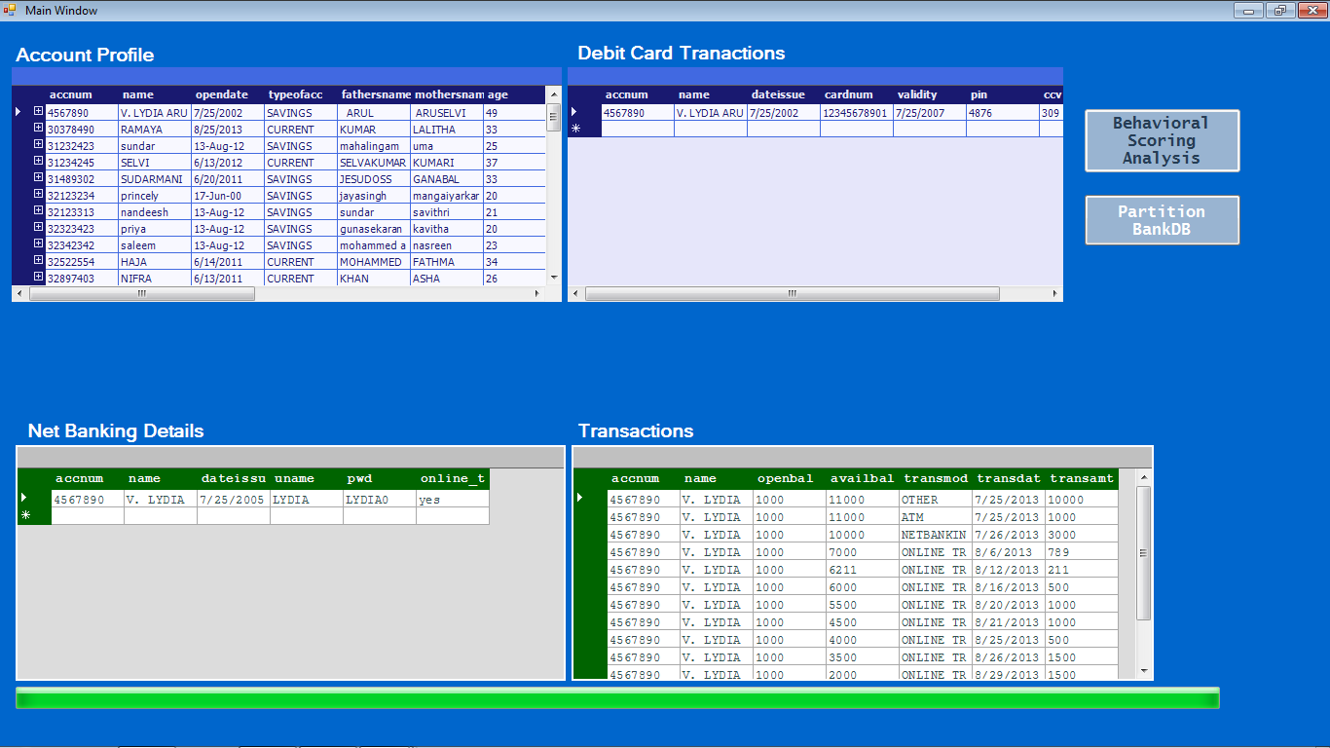

Behavioral Scoring Method:
Condition 1:

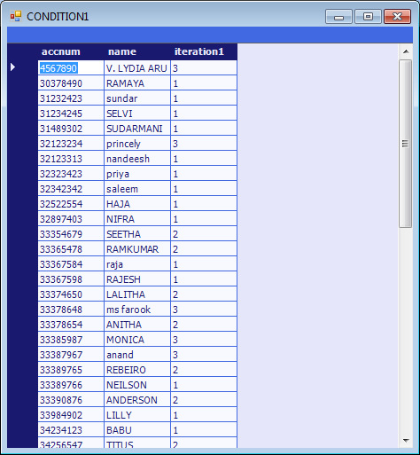

Condition 2:

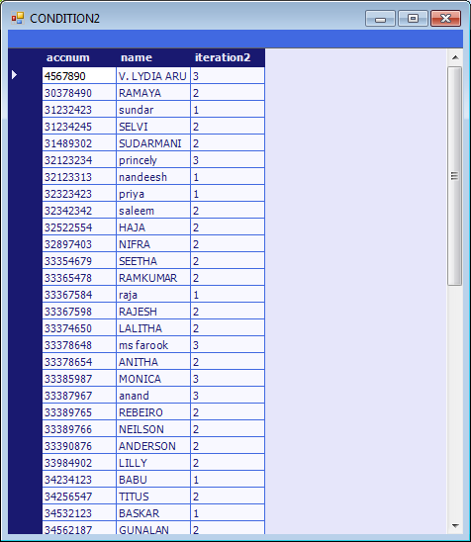

Condition 3:

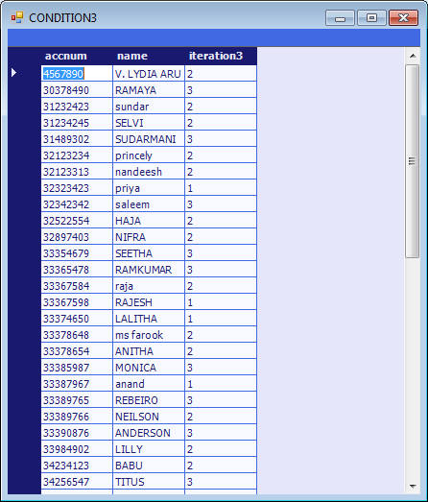

Condition 4:
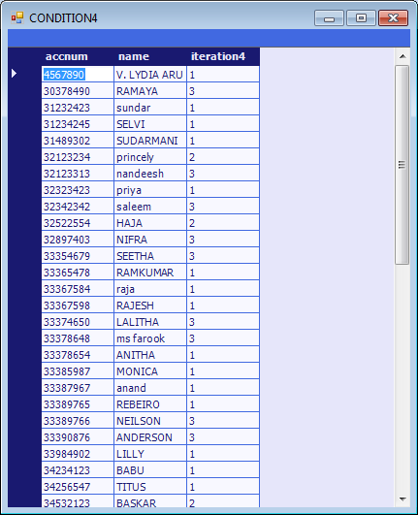

Condition 5:

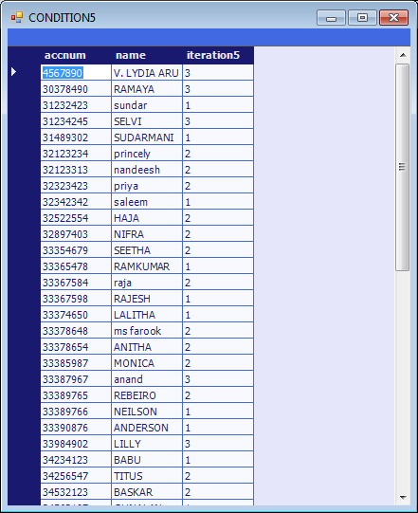

Condition 6:

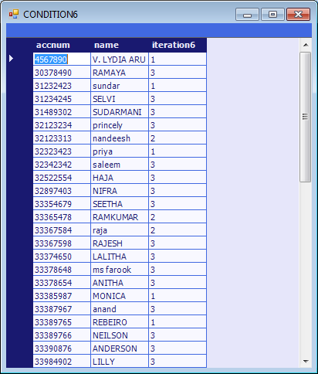

Condition 7:

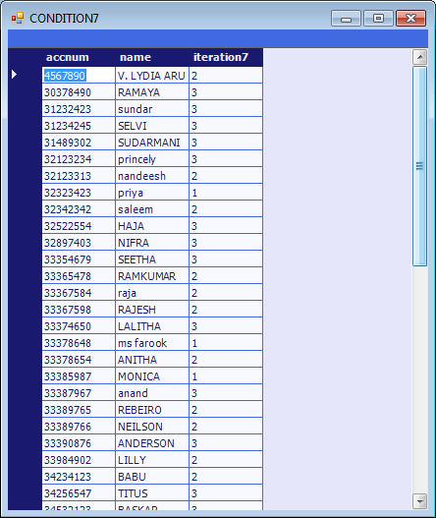

Condition 8:

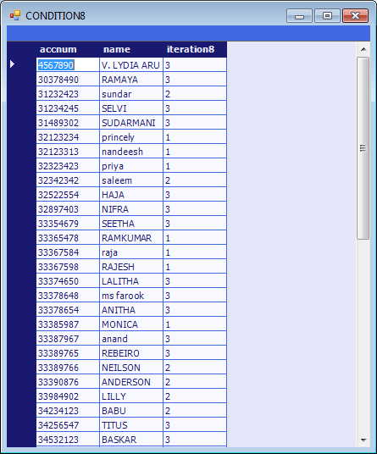

Condition 9:

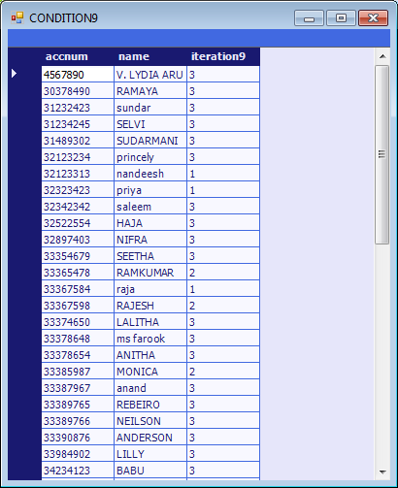

Condition 10:

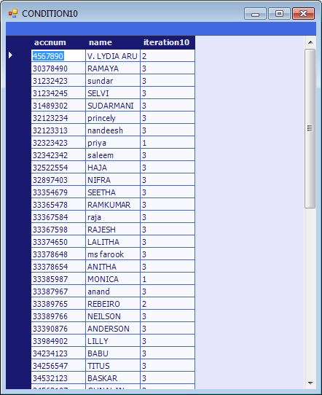

Condition 11:

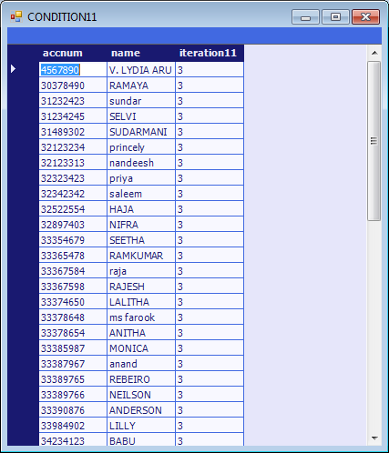

Partition BankDB:

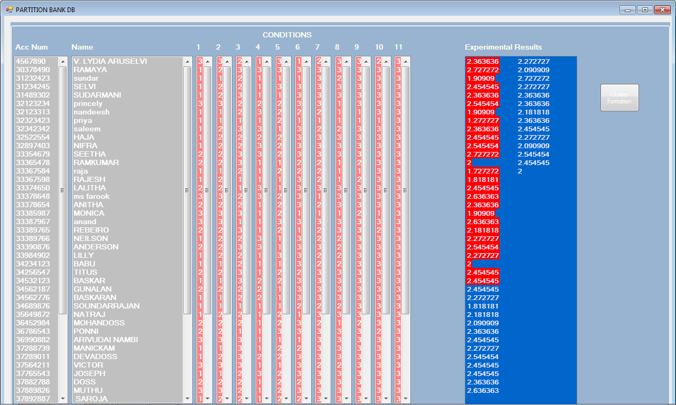

Assign DB+ and DB- Cluster:

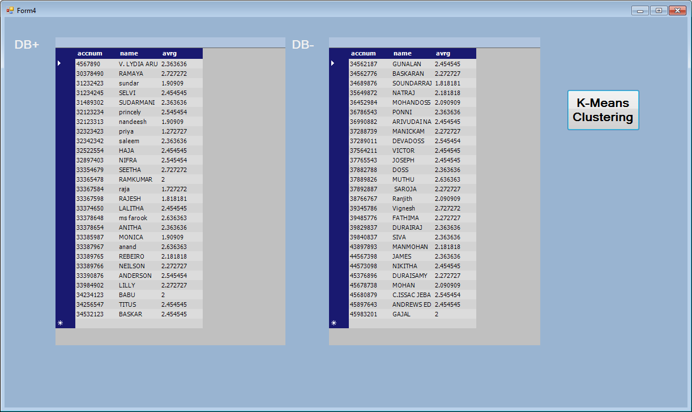

K-Means:

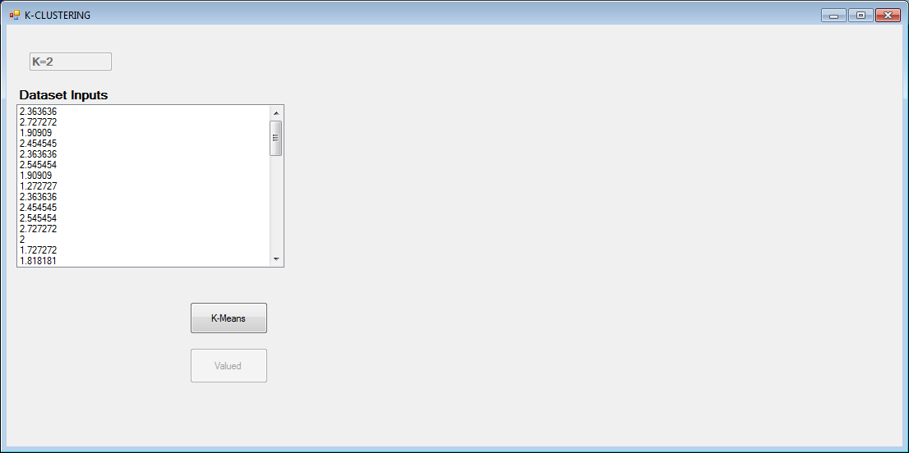

Cluster Formation

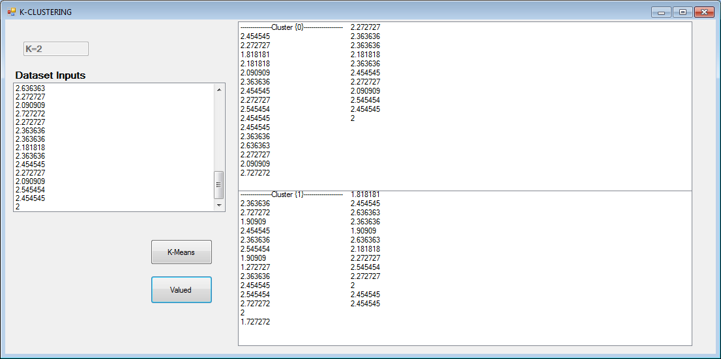

Final Result Vector:

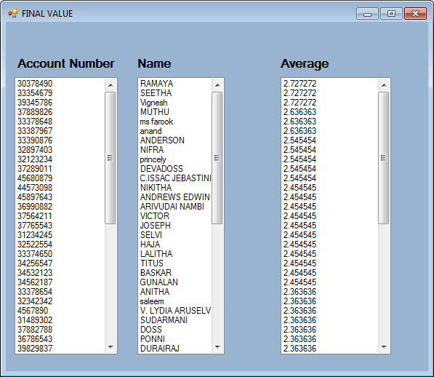

10. BIBLIOGRAPHY

BOOKS
- Matthew MacDonald, Beginning ASP.NET 3.5 in C# : From Novice to Professional, Second Edition in 2008
- Jessie Liberty, Programming C# by O’Reilly as First edition in July 2001
- Patrick Smacchia “Practical .Net2 and C#2 Harness the Platform, the Language, and the Framework “, 2005.
WEBSITES
- http://www.sourcefordgde.com
- http://www.almaden.ibm.com/software/quest/Resources
- http://www.computer.org/publications/dlib

